**THE BOURNEMOUTH**

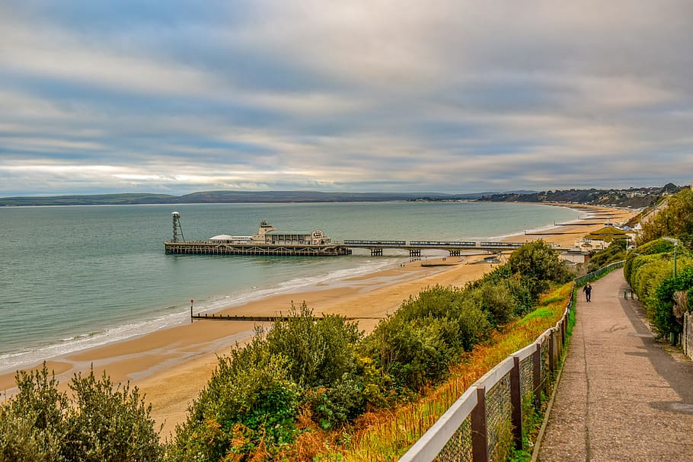Bournemouth is a [coastal resort](https://en.wikipedia.org/wiki/Coastal_resort) town in the [Bournemouth, Christchurch and Poole](https://en.wikipedia.org/wiki/Bournemouth,_Christchurch_and_Poole) unitary authority area in the [ceremonial county](https://en.wikipedia.org/wiki/Ceremonial_county) of [Dorset](https://en.wikipedia.org/wiki/Dorset), on the south coast of England. The built-up area had a population of 196,455 at the 2021 census, making it the largest town in Dorset. The town is part of the [South East Dorset conurbation](https://en.wikipedia.org/wiki/South_East_Dorset_conurbation).

Bournemouth grew into an important resort town, particularly following the arrival of the railway in 1870. It was [historically](https://en.wikipedia.org/wiki/Historic_counties_of_England) part of [Hampshire](https://en.wikipedia.org/wiki/Hampshire), but was transferred to Dorset in 1974. [Bournemouth Borough Council](https://en.wikipedia.org/wiki/Bournemouth_Borough_Council) was made a [unitary authority](https://en.wikipedia.org/wiki/Unitary_authority) in 1997, but was abolished in 2019 when the current unitary authority of [Bournemouth, Christchurch and Poole Council](https://en.wikipedia.org/wiki/Bournemouth,_Christchurch_and_Poole_Council) was created, also covering [Poole](https://en.wikipedia.org/wiki/Poole), [Christchurch](https://en.wikipedia.org/wiki/Christchurch,_Dorset) and adjoining areas.